“CRIME ALERT”
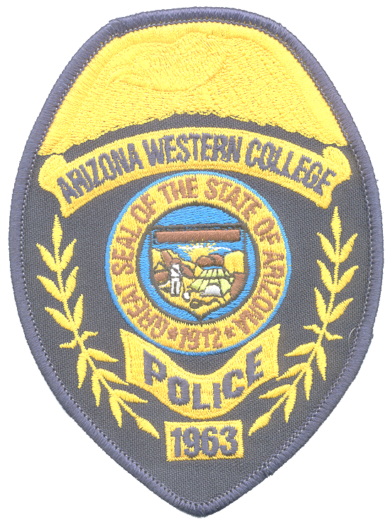

DATE: April 12, 2010

TIME: 1:00 P.M.

DESCRIPTION OF INCIDENT: Alleged Sexual Assault:

On April 11, 2010, at approximately 7:36 pm, a 20 year old male student reported that he was sexually assaulted in a residence hall. The victim was examined at Amberly’s Place, the Yuma Area Center for sexual assault victims. The three identified suspects were arrested and booked into the Yuma County Adult Detention Facility.

The investigation continues and upon completion will be submitted to the Yuma County Attorney’s Office for criminal filings.

Should you have any questions about this incident please contact

The A.W.C. POLICE DEPARTMENT at 314-9500 or 344-5555

