“CRIME ALERT”
False Report of Sexual Assault
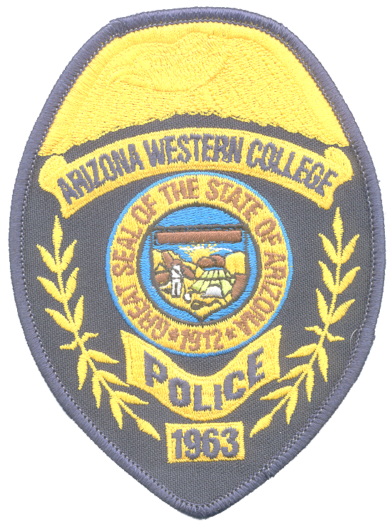

DATE: March 27, 2007

TIME: 07:30 A.M.

FALSE REPORT:
The sexual assault reported below did not occur; the reported victim has recanted her report:
DESCRIPTION OF INCIDENT: A 20 year old female student reported that she was sexually assaulted on 2/15/07 at 7:30 PM in parking lot #12. Victim advised that as she was returning to her vehicle she was assaulted from behind by one or two individuals who placed a cloth over her face.

Remember to be aware of your surroundings
Park in designated parking areas
Walk with others to and from your vehicle whenever possible
Look around and underneath your vehicle before approaching
Be cautious around individuals you do not know
If you need an escort call the A.W.C. Police Department

Should you have any information about this crime please contact

The A.W.C. POLICE DEPARTMENT at 314-9500 or 344-5555

