“CRIME ALERT”
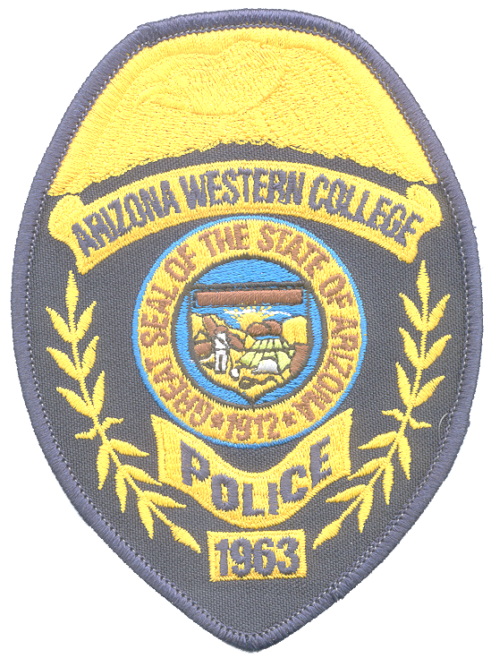

DATE: Feb. 15, 2007

TIME: 07:30 P.M.

DESCRIPTION OF INCIDENT: Sexual Assault:
A 20 year old female student reported that she was sexually assaulted on 2/15/07 at 7:30 PM in parking lot #12. Victim advised that as she was returning to her vehicle she was assaulted from behind by one or two individuals who placed a cloth over her face. No suspects have been arrested or identified at this time. No weapons were used during this attack. Amberly’s Place, a center for sexual assault victims, is providing services for this investigation and to the victim. If you have any information regarding this incident, contact the Campus Police at 314-9500.

Remember to be aware of your surroundings
Park in designated parking areas
Walk with others to and from your vehicle whenever possible
Look around and underneath your vehicle before approaching
Be cautious around individuals you do not know
If you need an escort call the A.W.C. Police Department

Should you have any information about this crime please contact

The A.W.C. POLICE DEPARTMENT at 314-9500 or 344-5555

