**You are HERE, Matador!**

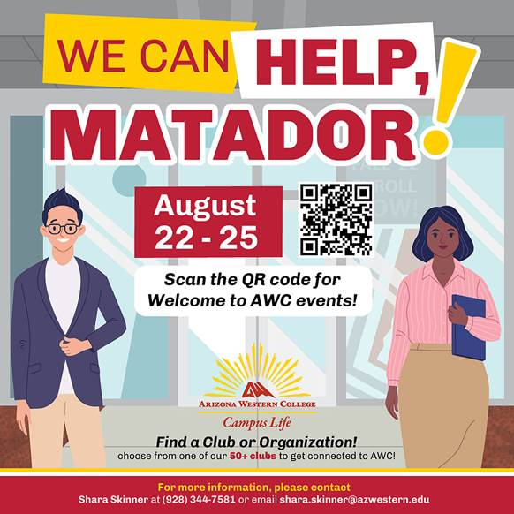We are so glad you joined us!  Whether you are transferring here, starting new with us, or you are back after an extended break we could not be happier that you are here. We want you to feel supported while here,  please start your journey by taking a look at the [Arizona Western College Student Handbook](https://issuu.com/arizona_western_college/docs/awc_20_21_studenthandbook) today!

There are *a lot* of campus resources and you may have a variety of questions on the first week of class and perhaps you aren’t familiar with all of the great things AWC has to offer.  **Please utilize Campus Life as a valuable tool and direct any questions our way so that we may assist you!** [**Email Us Here**](mailto:shara.skinner@azwestern.edu)

There is assistance at every corner at AWC, starting with the [Student Success Center](https://www.azwestern.edu/student-success-center/about-us) which offers programs to keep students on the road to graduation and professional success, such as tutoring and workshops. Help students looking for a quiet place to study by encouraging them to visit the newly remodeled  [Academic Library](https://www.azwestern.edu/library) and explore its resources and services to support your coursework. [Career Services](https://www.azwestern.edu/student-support/career-services) is a gateway to online job preparation and virtual internships. [Andale’s Food Pantry](https://www.azwestern.edu/student-life/food-pantry) provides basic needs support. Visit [Student Leadership and Activities](https://www.azwestern.edu/student-life/student-activities) to help students stay engaged! Finally [Student Health and Wellness](https://www.azwestern.edu/student-life/health-and-wellness) offers personal counseling and other wellness resources.

**Explore Campus & Resources**

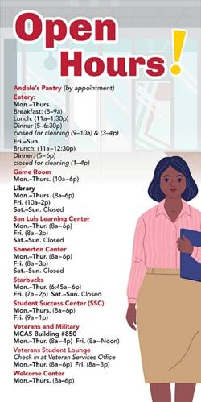This is the perfect time to get to know our **beautiful campus** for our students and all the **helpful support services**we have to offer. We hope you support useful workshops from student groups and campus departments on everything from time management to mental health. We hope you also make time to get involved in social and school spirit events planned throughout the year! See our [Campus Calendar](https://www.azwestern.edu/calendar) and our [Athletics Schedules](https://www.awcmatadors.com/).

**A Focus on *Student*Community Building**

Getting involved in a club or organization will be one of the highlights of our students time at Arizona Western. Whether they are a perfect-GPA-volunteers-never misses a class kind of student, or a stay-out-late-on-Thursday, cram-for-tests-personal-growth type of student, there’s an activity and a home here for them. In many cases, our clubs will connect them to a network of like-minded groups, individuals, and possibly even future employers.  [See our list of Clubs HERE.](https://www.azwestern.edu/student-life/clubs-and-organizations)

**Student Experience**

We are devoted to making every students experience the best there is supported by our Student Experience Statement characterized by:  
• A connected community within which students are encouraged,  
challenged, and feel they belong;  
• Programs developed and aligned with employment opportunities;  
• A clear path to success and completion;  
• Flexible, accessible services and learning approaches;

• Contemporary technology that supports and enhances the AWC experience