Preliminary Summary
SWOT
February 25th 2017, 12:04 pm MST
Q2#1 - Work schedule

# | Question | FT | PT | Total
1 | Classified employee | 63% | 38% | 56
2 | Faculty | 74% | 26% | 80
3 | Professional/Administrative employee | 93% | 7% | 69
4 | District Governing Board member | 0% | 100% | 1

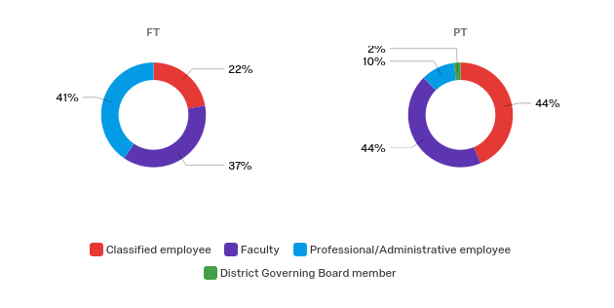

Q2#2 - Years worked at AWC
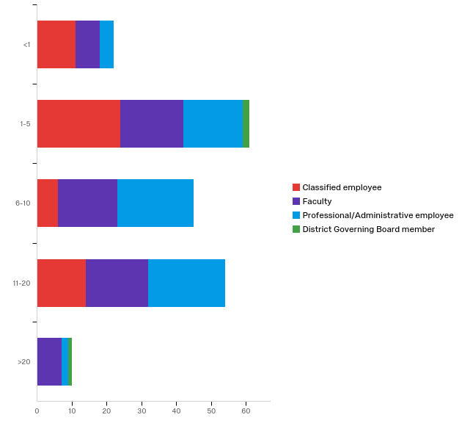

# | Question | <1 | 1-5 | 6-10 | 11-20 | >20 | Total
1 | Classified employee | 20% | 44% | 11% | 25% | 0% | 55
2 | Faculty | 10% | 27% | 25% | 27% | 10% | 67
3 | Professional/Administrative employee | 6% | 25% | 33% | 33% | 3% | 67
4 | District Governing Board member | 0% | 67% | 0% | 0% | 33% | 3

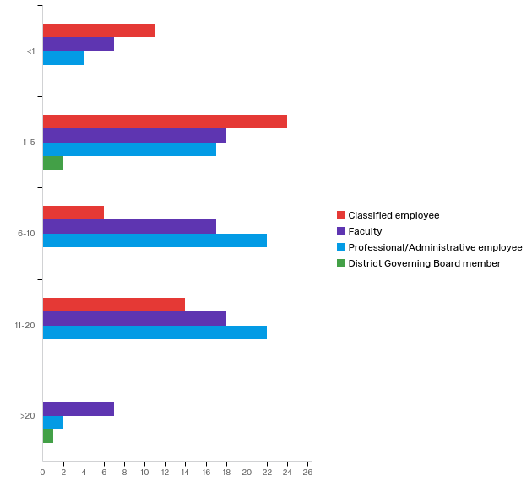
Q3 - Location I most identify with  # | Answer | % | Count
 | Total | 100% | 196
1 | Downtown | 3% | 6
2 | MCAS/YPG | 0% | 0
3 | Parker | 5% | 10
4 | Quartzsite | 0% | 0
5 | San Luis | 7% | 13
6 | Somerton | 4% | 7
7 | Yuma | 80% | 157
8 | Wellton | 1% | 1
9 | Online (faculty) | 1% | 2

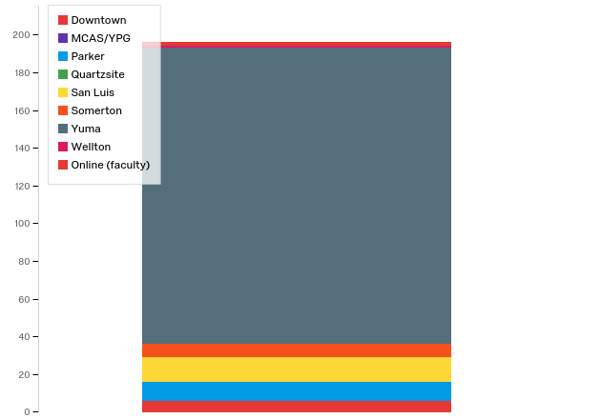
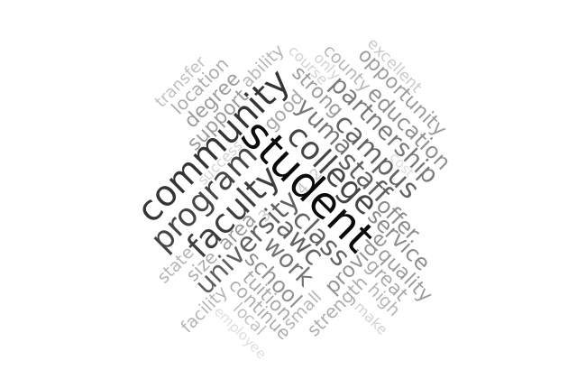
Q4 - What STRENGTHS does Arizona Western have that should be leveraged and/or sustained in order to ensure the continued growth and quality of the College?

Q4 - Topics | Percentage
faculty/staff | 35%
community | 28%
cost | 27%
programs | 26%
learning centers | 22%
location | 22%
university | 22%
partnerships | 20%
student services | 20%
climate/environment | 14%
transfer | 12%
facilities | 12%
other | 12%
course availability | 12%
class size | 12%
diversity | 10%
student academic supports | 9%
CTE programs | 9%
students | 8%
open access | 7%
distance ed | 6%
educational experience | 6%
leadership | 6%
technology | 6%
quality | 6%
residence | 6%
campus | 5%
external funding | 4%
focus | 4%
communication | 3%
training/lifelong learning | 2%
flexibility to innovate | 2%
fiscal responsibility | 2%
customer service | 2%
various learning modes | 2%
KAWC/public media | 1%
retention/completion | 1%
PR | 1%
data | 1%
teaching/learning | 1%
compensation | 1%
hiring | 1%
"resources" | 1%
AWC Foundation | 1%
website | 1%
professional learning | 1%
Total | 100%
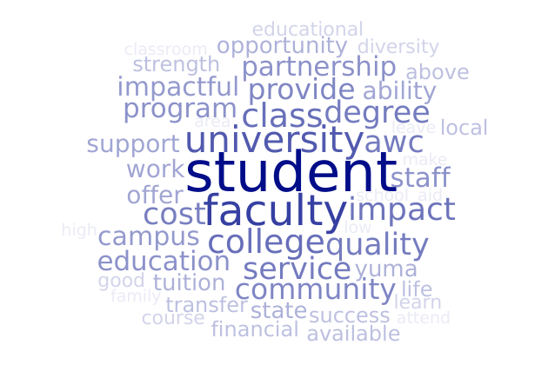
Q5 - Of the STRENGTHS you identified, which is most impactful to AWC students?
Q5 - Topics | Percentage
faculty | 24%
cost | 16%
program | 14%
quality learning | 13%
student services | 13%
other | 12%
university partnerships | 12%
staff | 9%
location | 7%
transfer | 5%
community | 4%
schedule | 4%
ITN, web, or distance learning | 4%
climate | 3%
environment | 3%
technology | 3%
NA | 3%
diversity | 3%
occupational | 3%
grant | 3%
equipment, resources, facilities | 2%
learning centers | 2%
open enrollment | 2%
mentor | 1%
writing | 1%
class size | 1%
internships | 1%
customer service | 1%
student academic supports | 1%
second language | 1%
leadership | 1%
residence | 1%
Total | 100%

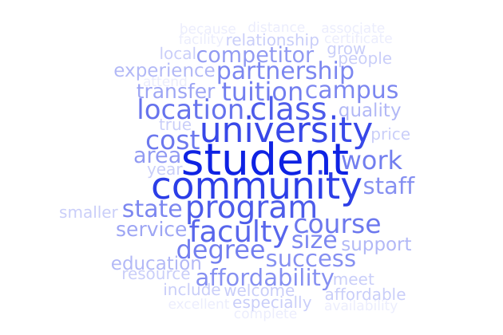
Q6 - Of the STRENGTHS you identified, which best positions AWC against college and university competitors?

Q6 - Topics | Percentage
cost | 22%
location | 19%
partnerships | 12%
faculty | 12%
other | 12%
program | 11%
community support | 8%
class size | 8%
student supports | 7%
institutional climate | 7%
educational excellence | 6%
NA | 6%
learning centers | 4%
residence | 4%
transfer | 3%
class availability | 3%
external funding/advancement | 2%
staff | 2%
facilities | 2%
student success | 2%
technology | 2%
open enrollment | 1%
completion | 1%
diversity | 1%
marketable skills | 1%
CTE | 1%
culture/climate | 1%
adapt/innovate | 1%
compensation | 1%
recruiting | 1%
assessment | 1%
vision | 1%
Total | 100%

Q7 - What OPPORTUNITIES will position the College to thrive through 2025?
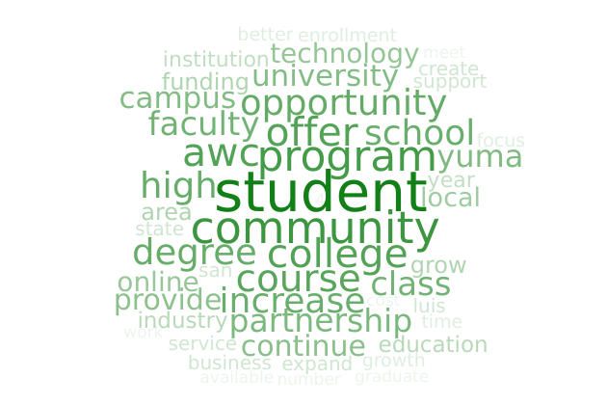
Q7 - Topics | Percentage
partnerships | 25%
community | 24%
programs/credentials | 21%
other | 18%
class availability | 14%
technology | 14%
university partnerships | 12%
learning centers | 11%
faculty/staff | 11%
excellent learning/rigor | 9%
external funding | 9%
flexibility/innovation | 8%
marketable skills | 8%
cost | 8%
distance ed | 8%
recruitment | 7%
marketing/pr | 6%
internship or svc learning | 5%
facilities | 5%
CTE | 5%
internationalization | 5%
transfer | 5%
location | 4%
compensation | 4%
workforce training | 4%
lifelong learning | 3%
focus | 3%
NA | 3%
students first priority | 3%
enrollment | 3%
residence halls/campus life | 3%
student services | 3%
professional learning | 2%
customer service | 2%
data | 1%
climate/environment | 1%
leadership | 1%
decision making | 1%
funding | 1%
dining services | 1%
HR | 1%
strategic | 1%
equity | 1%
Unknown | 1%
transportation | 1%
Total | 100%
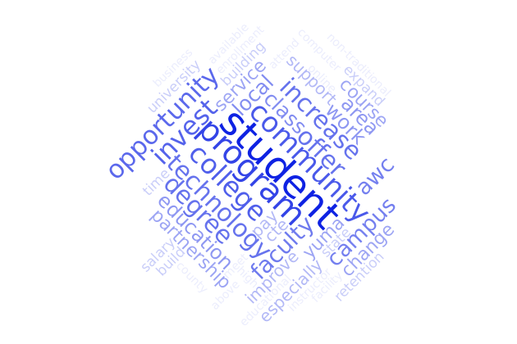
Q8 - Of the OPPORTUNITIES you identified, which ONE would you invest in to ensure the long-term viability of the College?

Q8 - Topics | Percentage
other | 16%
partnerships | 15%
programs | 15%
community benefit | 11%
technology | 8%
course availability | 8%
facilities | 7%
faculty | 6%
enrollment/retention | 4%
outlying areas | 4%
recruitment | 4%
instruction | 3%
compensation | 3%
funding | 3%
internship | 3%
student success | 3%
professional learning | 3%
NA | 3%
distance ed | 2%
advising | 1%
cost | 1%
workforce training | 1%
staff | 1%
lifelong learning | 1%
CTE | 1%
educational prep | 1%
HR | 1%
marketing | 1%
communication | 1%
location | 1%
residence | 1%
Total | 100%
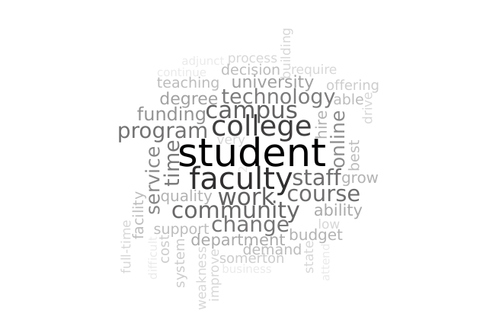
Q9 - What WEAKNESSES will hamper Arizona Western’s ability to meet the changing demands of higher education and thus inhibit the College’s ability to thrive?
Q9 - Topics | Percentage
funding | 23%
adaptive/change | 21%
technology | 20%
other | 18%
faculty | 14%
class availability | 11%
infrastructure | 10%
community | 10%
quality | 10%
academic programs | 9%
learning services | 9%
decision making | 8%
student services | 8%
compensation | 7%
location | 7%
equity | 7%
HR | 5%
university | 5%
part-time | 4%
cost to students | 3%
residence | 3%
don't know | 3%
staffing | 3%
marketing and pr | 3%
grants | 3%
professional learning | 3%
transfer | 2%
recruiting | 1%
growth | 1%
learning centers | 1%
data | 1%
Spanish | 1%
focus | 1%
communication | 1%
library | 1%
admin services | 1%
class size | 1%
CTE | 1%
Total | 100%

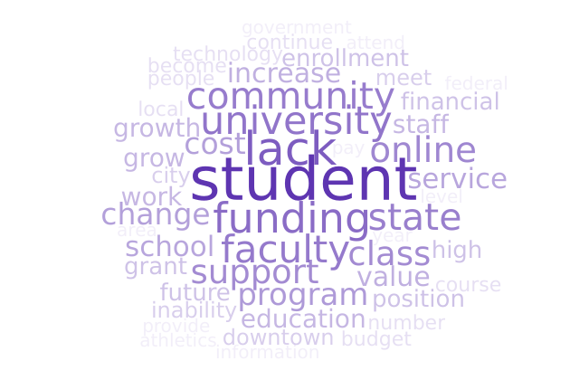
Q10 - What THREATS could impede the College’s growth and viability?
Q10 - Topics | Percentage
funding | 25%
other | 19%
4-year university | 17%
community | 13%
political and policy concerns | 11%
enrollment | 11%
change | 9%
cost | 7%
distance ed | 7%
class availability | 7%
technology | 7%
recruitment | 6%
faculty | 5%
grants | 5%
focus | 5%
communication | 4%
quality | 4%
infrastructure | 4%
program costs | 4%
financial aid | 3%
employee retention | 3%
federal regulations | 3%
compensation | 3%
learning centers | 3%
vision | 2%
NA | 2%
planning | 2%
CTE | 2%
lawsuits | 1%
staff | 1%
diversity | 1%
decision making | 1%
marketing/pr | 1%
process | 1%
safety | 1%
hiring | 1%
load | 1%
leadership | 1%
cyber security | 1%
strategic planning | 1%
customer service | 1%
student preparation | 1%
transportation | 1%
residence | 1%
Total | 100%

