
Admission Quick Guide
- Visit: https://azwestern.elluciancrmrecruit.com/Apply/Account/Login?ReturnUrl=%2fApply
- Click, create account.
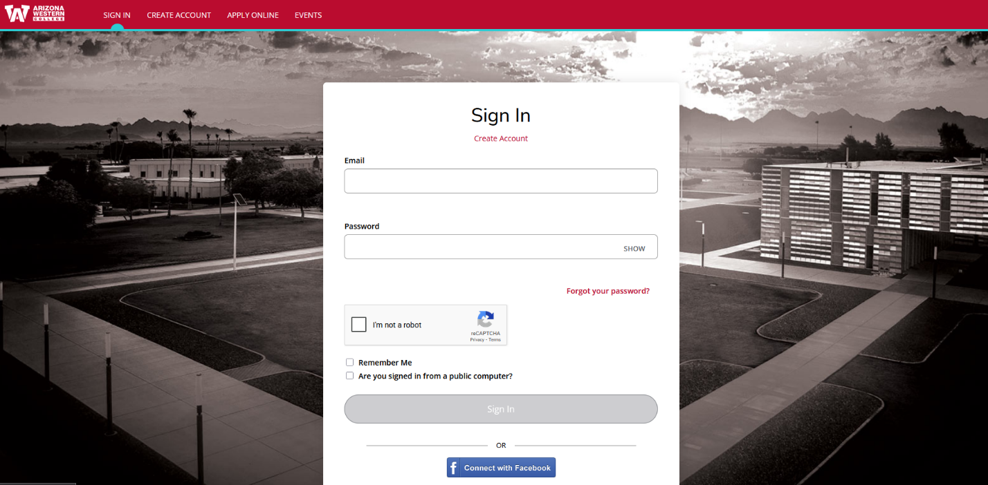

- Enter contact information.
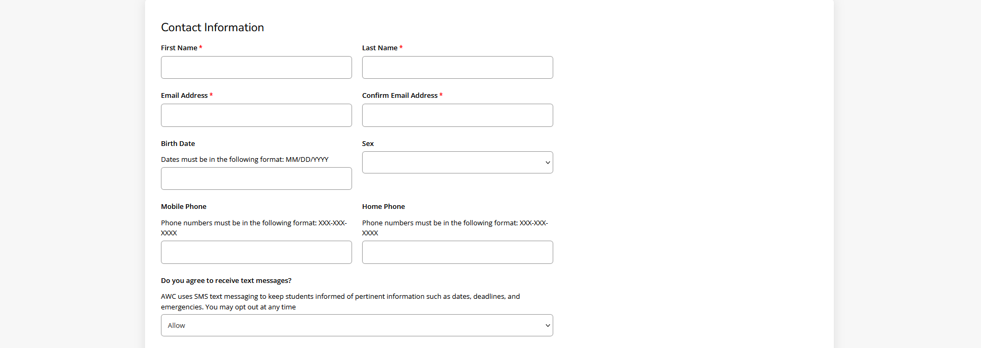

- Check the box if the address is outside of the U.S. or Canada.

- Type the address, and make sure the foreign address is typed twice.
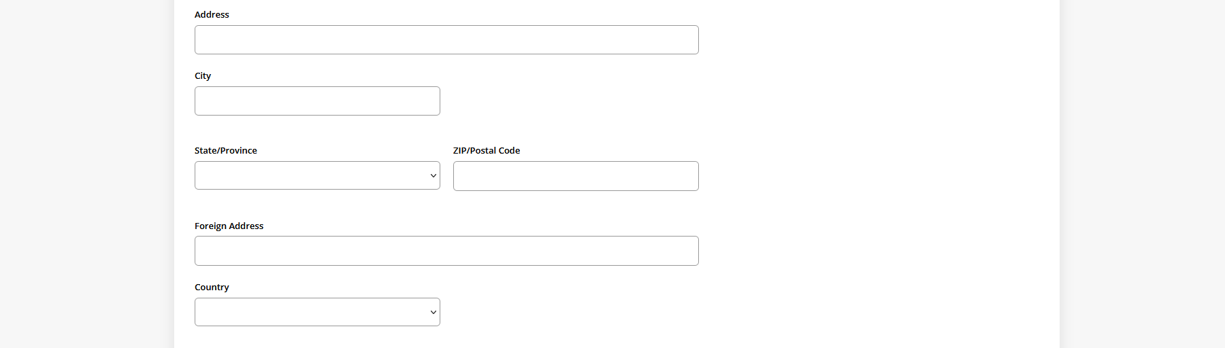
- Under GED Information, select yes or no.

- High School Information (Optional). Click add.


- Enter the high school name and country or select the box if you were home-schooled for high school.
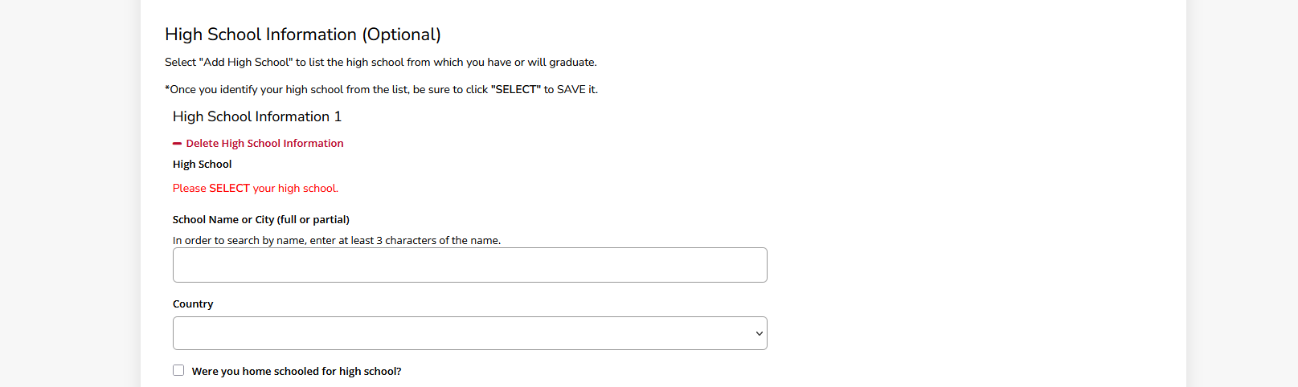

- Under Academic Interests, select international student.
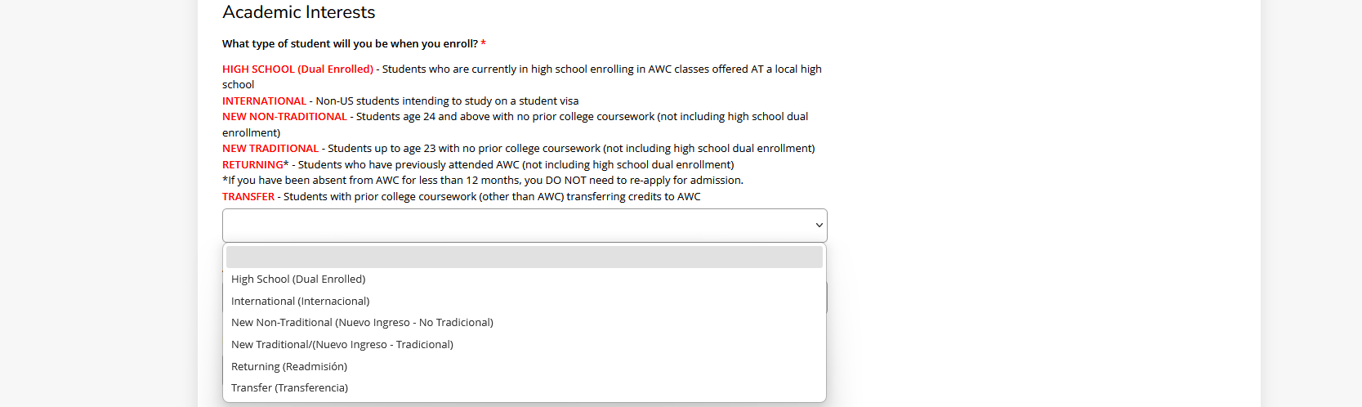
- Select the anticipated entry term and field of study.
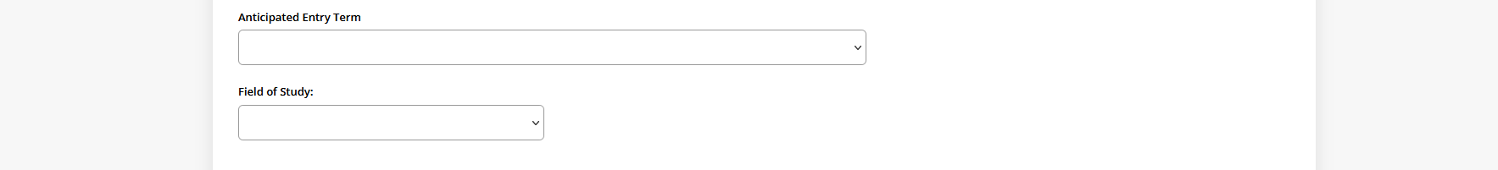

- Answer verification question, type the answer in the box.

- Under account information, create a password that includes an upper case, lower case, numbers and a special character.
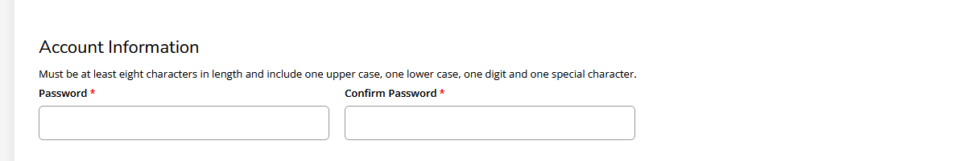

- Select, I’m not a robot BOX.

- Click, CREATE ACCOUNT.


- Once your account has been created, you can proceed with your admission application process by selecting option 4 for AWC International Student.

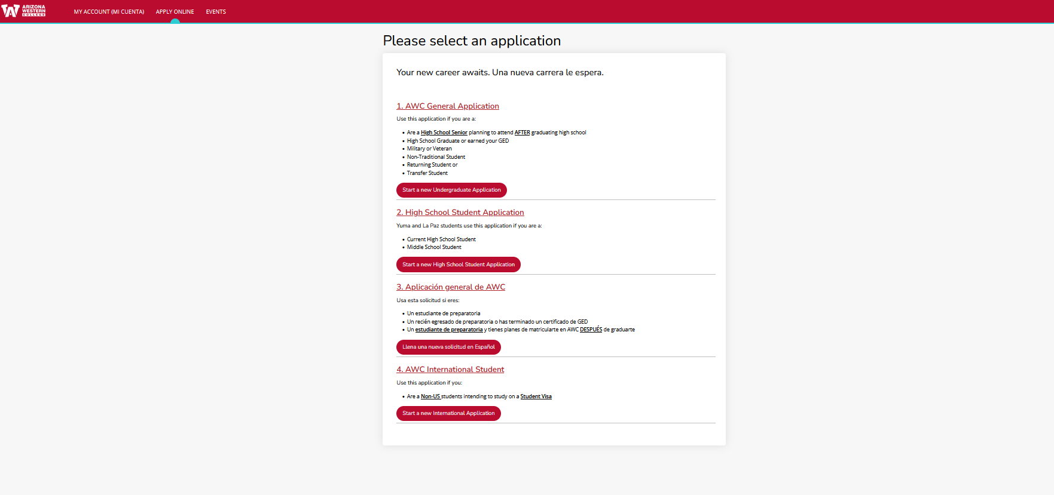

- Under area of interest, select New International (Nuevo Ingreso International).
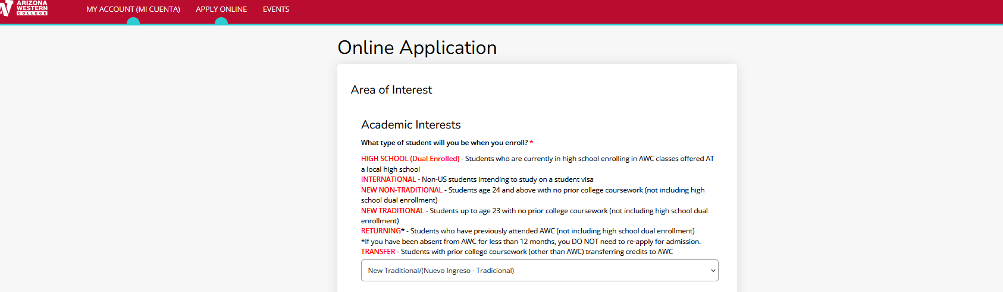

- Select the anticipated entry term.


- Select Field of Study.

- Answer Verification Question, then click Submit.
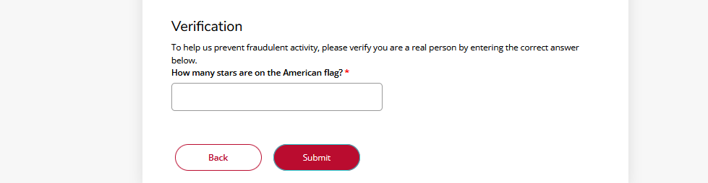
- Enter your first name, last name, sex, and date of birth. 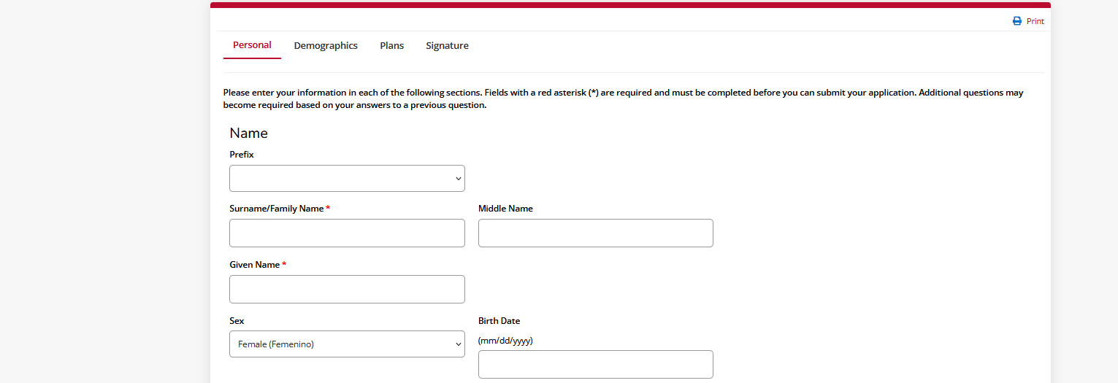

- Enter your Permanent Mailing Address and check the box for an address outside of the U.S. or Canada. 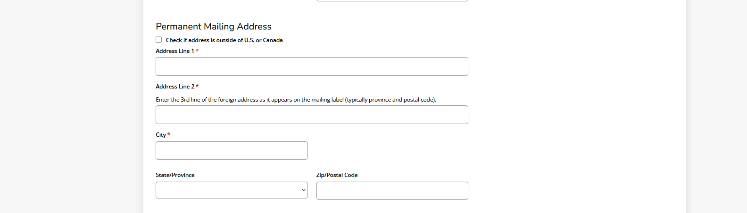
- Enter contact information, then click Save and Continue.
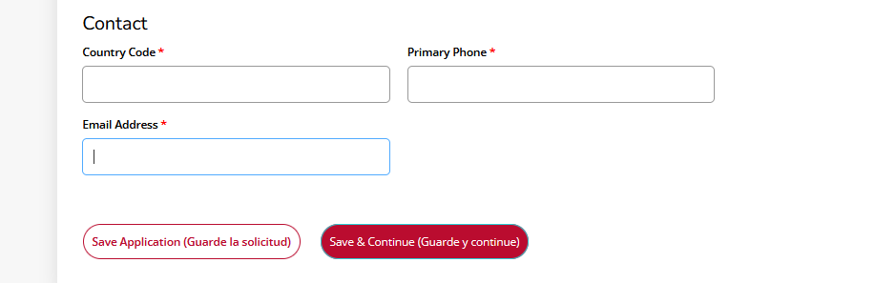

- Enter your demographics information.
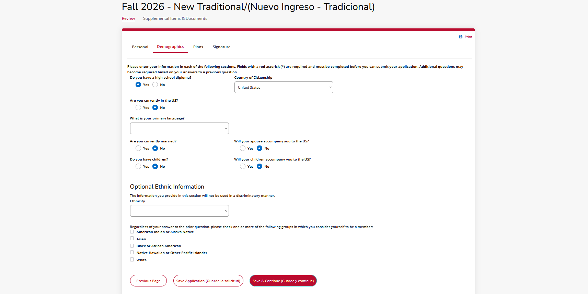

- Enter your Academic Plans, then click Save & Continue.
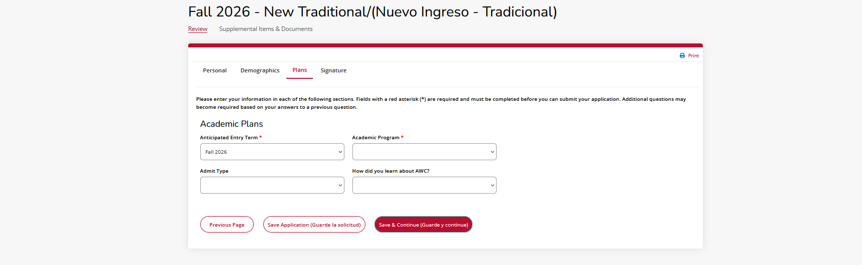

- Complete your application by answering the certification questions, entering your electronic signature and date, and finally clicking Submit Application.
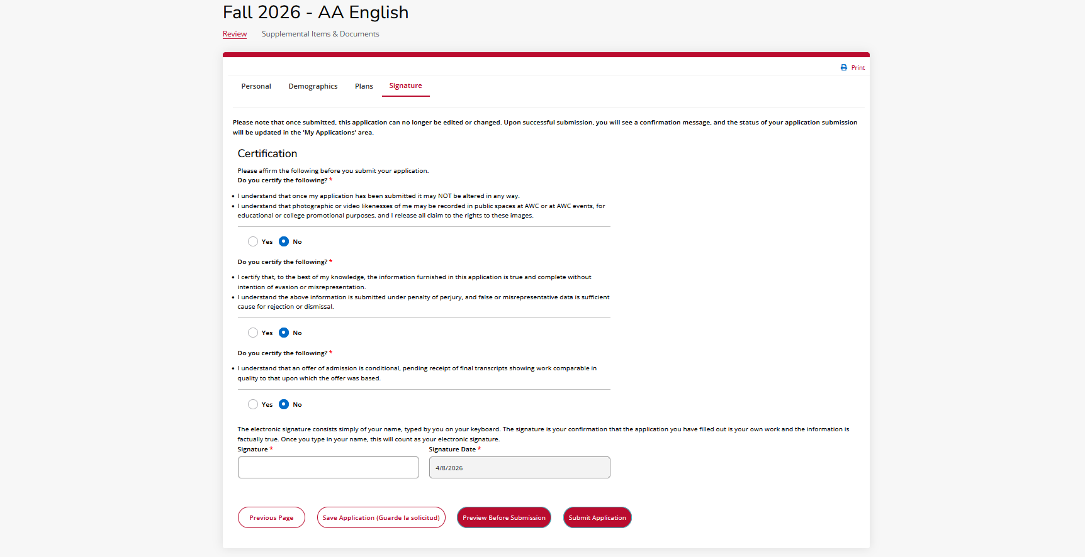

Note: After submitting the admission application, you will receive a follow-up email with instructions to upload the required supplemental documents to finalize your admission application as an international student.

